1. **Palak Dave**

**FYIT/132**

**PRACTICAL 1: Creating account, repository on GitHub and Cloning repository in GitHub Page**

**a) Steps to create account:**

1. Search Github.com on any browser.
2. Click on Sign Up and create an account.

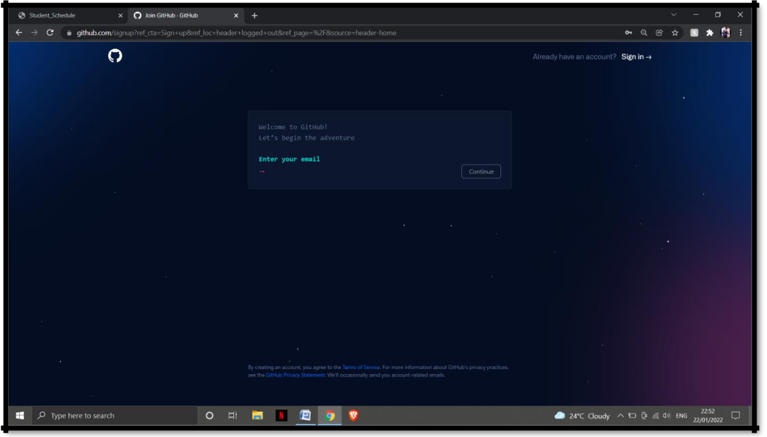

3. Enter the details and account will be created.

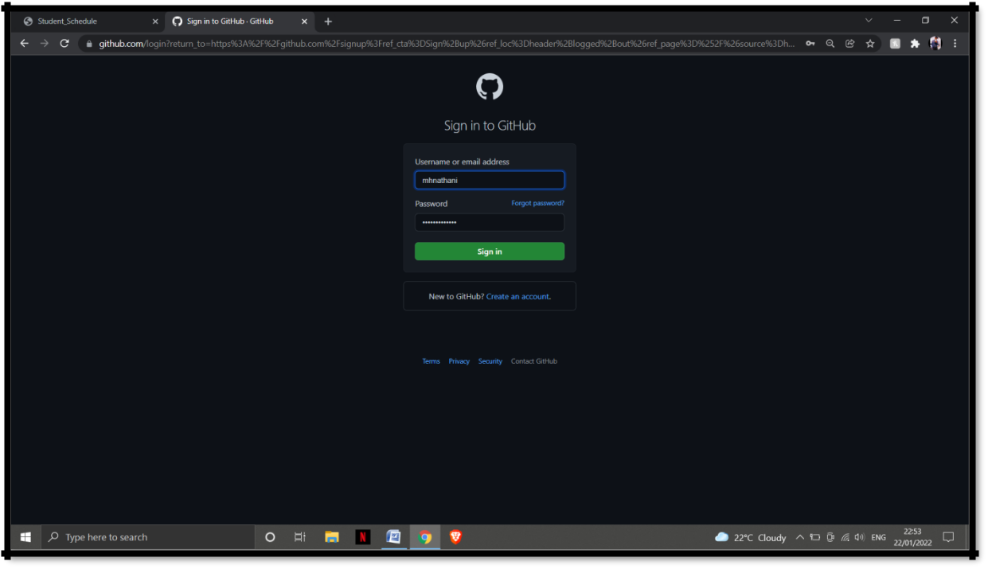

1

**M. Palak Dave**

**FYIT/132**

**b) Steps to create repository:**

1. Sign in to your GitHub account.
2. Click on New button on left panel.

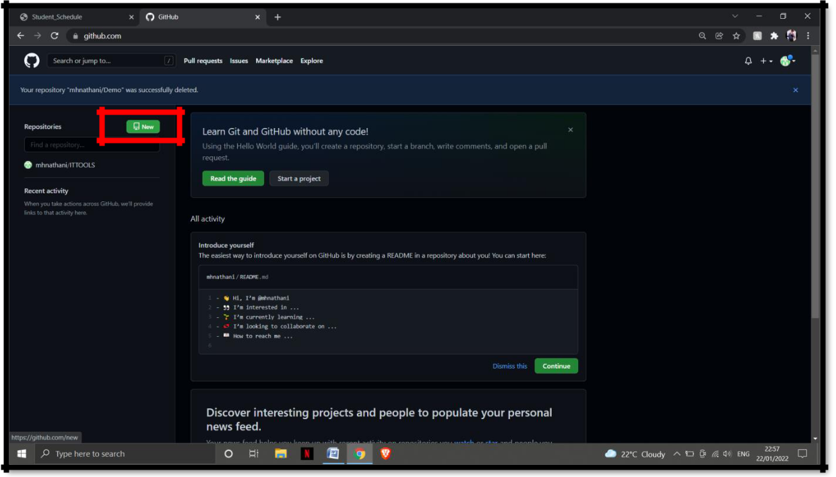

2

3. Enter a name for the repository, and then click on Create Repository button at the end.

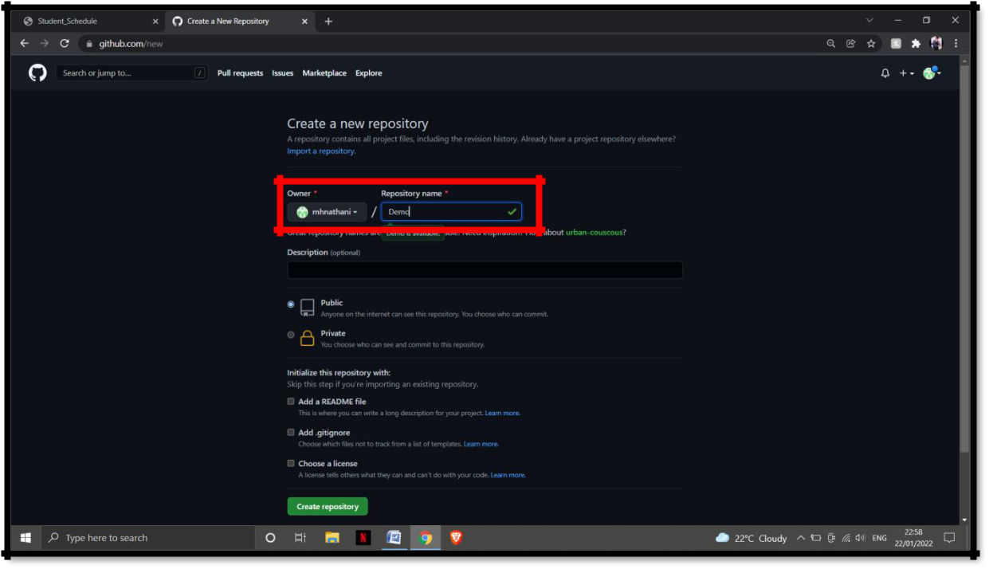

**M. Palak Dave**

**FYIT/132**

3

Repository created.

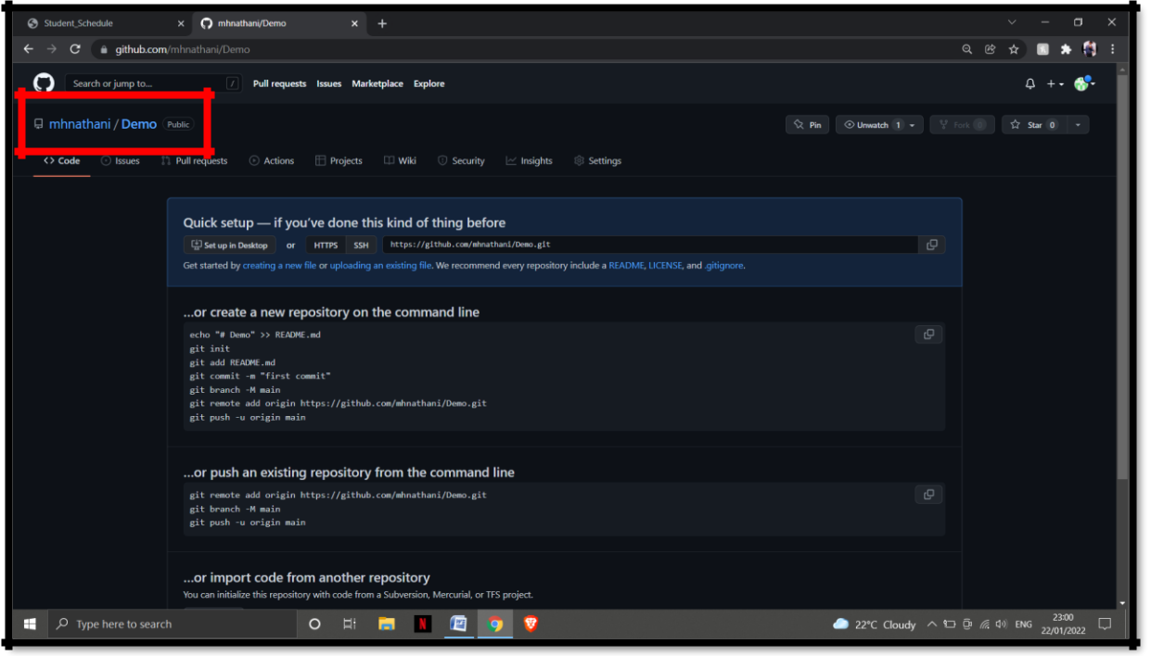

**M. Palak Dave**

**FYIT/132**

4

**c) Cloning Repository:**

To clone the Repository, copy the link of your repository and share.

https://github.com/mhnathani/Demo.git

